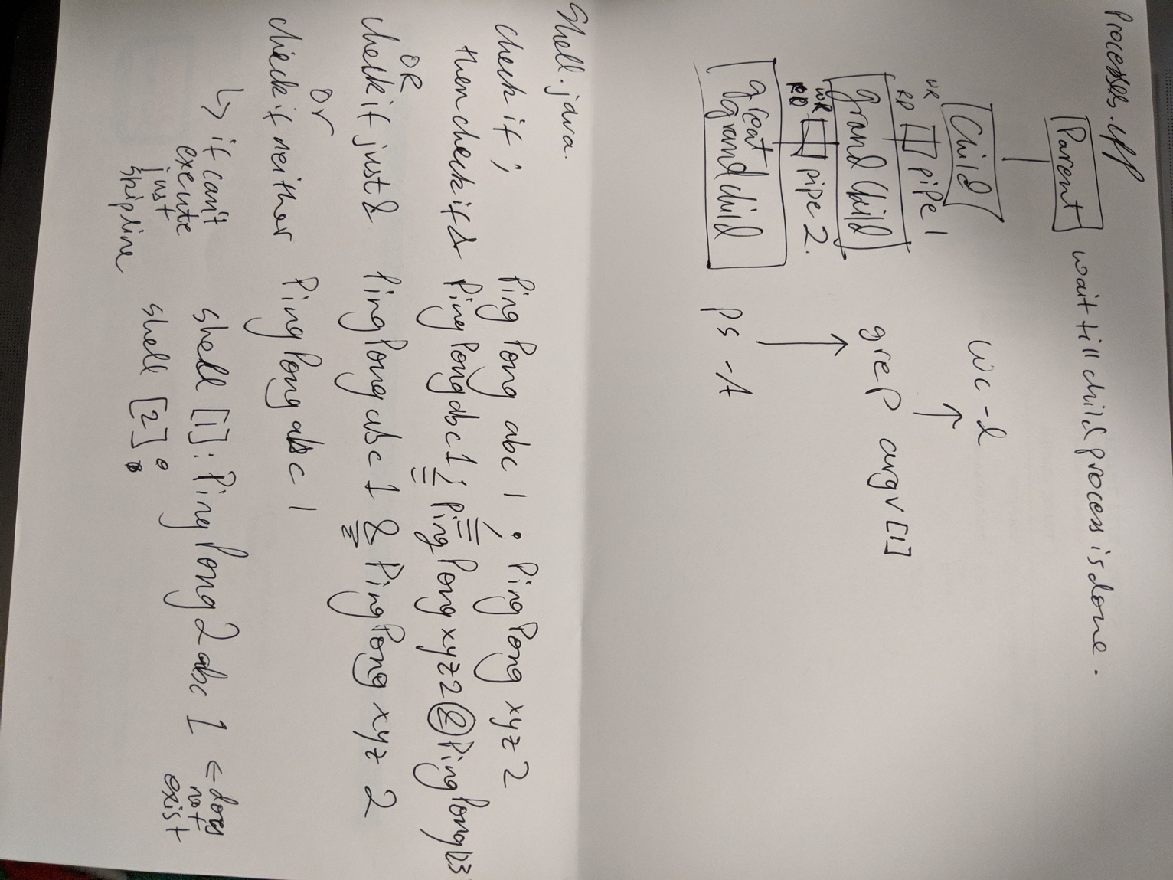

Process.cpp creates 4 processes: parent, child, grandchild, and great-grandchild. The latter 3 of the 4 each execute a shell command. They do so by using the execlp function. Greatgrandchild runs the ps command, the grand child then runs grep command and uses the argument given by the user to look for that specific process.

Child then runs word count. The parent waits till everything is done.

Shell.java essentially executes Thread OS programs concurrently or sequentially. It does so by finding either ; or & in the command. It then appropriately, by string manipulation; determines how to run the command.

Shell.java can be tested by using the commands provided in the P1 program description page.

